Overall Description and Motivation

Friday, April 22, 2016

3:21 PM

This project describes a set of simple optics holders that can be made from common hardware (acrylic, steel screws, neodymium magnets) and acrylic cut using a laser cutter.

To do optics experiments you need a way to hold the components (lenses, lasers, gratings, and whatnot) at a particular height and particular orientation. For example, a laser holder will need a way to adjust the "aim" of the laser up/down and left/right so that the beam lines up with the optical axis of the other components.

Existing holders are usually complex, and therefore expensive.

This project describes a set of aim-able optical holders that can be constructed from commonly available hardware and pieces cut using a laser cutter.

It's meant as a low-cost teaching tool for high-schools and home experimenters.

Although inexpensive, the system can make variety of interesting and subtle optical setups, such as:

* Laser Interferometry
* Design and development of different lens systems
* Measure the speed of light
* Measurements of lens type and focal point
* Fluorescence Microscope

Overall configuration

Friday, April 22, 2016

9:33 AM

[Base Plate](onenote:Description.one#Base%20Plate&section-id={578DE322-CBB4-4FD1-A0D8-F9C48A6B746A}&page-id={2C73F9A1-0FFD-41EA-BCA5-6919AEA501C4}&base-path=https://d.docs.live.net/064d22c33a172dde/Documents/Lasercut Optics Bench)

[Component Holders](onenote:Description.one#Component%20Holders&section-id={578DE322-CBB4-4FD1-A0D8-F9C48A6B746A}&page-id={044336F3-D5DA-430B-8E05-55947B25143C}&base-path=https://d.docs.live.net/064d22c33a172dde/Documents/Lasercut Optics Bench)

[Filter mount](onenote:Description.one#Filter%20Holder&section-id={578DE322-CBB4-4FD1-A0D8-F9C48A6B746A}&page-id={76ABE353-C060-4293-9535-E50DF49D42D9}&base-path=https://d.docs.live.net/064d22c33a172dde/Documents/Lasercut Optics Bench)

[Lens mount](onenote:Description.one#Lens%20Mount&section-id={578DE322-CBB4-4FD1-A0D8-F9C48A6B746A}&page-id={03DBB5C4-AC26-4D82-944B-4DBA9B7747AC}&base-path=https://d.docs.live.net/064d22c33a172dde/Documents/Lasercut Optics Bench)

[Mirror mount](onenote:Description.one#Mirror%20Mount&section-id={578DE322-CBB4-4FD1-A0D8-F9C48A6B746A}&page-id={CD10AE76-6455-4201-BEE2-479A998907D9}&base-path=https://d.docs.live.net/064d22c33a172dde/Documents/Lasercut Optics Bench)

Prism mount

[Polarizer mount](onenote:Description.one#Polarizer%20Mount&section-id={578DE322-CBB4-4FD1-A0D8-F9C48A6B746A}&page-id={78FD1E84-A908-4886-A348-90F4EE3FFC9B}&base-path=https://d.docs.live.net/064d22c33a172dde/Documents/Lasercut Optics Bench)

Optical Window mount

[Iris Diaphragm mount](onenote:Description.one#Iris%20diaphragm%20mount&section-id={578DE322-CBB4-4FD1-A0D8-F9C48A6B746A}&page-id={FADAC7BA-498A-4F0D-9E3F-658A3A57B195}&base-path=https://d.docs.live.net/064d22c33a172dde/Documents/Lasercut Optics Bench)

[Reticle mount](onenote:Description.one#Reticle%20Mount&section-id={578DE322-CBB4-4FD1-A0D8-F9C48A6B746A}&page-id={2C634520-8AFD-4395-BE33-32ECF5BC0E17}&base-path=https://d.docs.live.net/064d22c33a172dde/Documents/Lasercut Optics Bench)

Eyepiece mount

[Laser mount](onenote:Description.one#Laser%20Mount&section-id={578DE322-CBB4-4FD1-A0D8-F9C48A6B746A}&page-id={87B15ACB-0D61-42ED-AA61-26929DFE9C79}&base-path=https://d.docs.live.net/064d22c33a172dde/Documents/Lasercut Optics Bench)

[Diode mount](onenote:Description.one#LED%20Mount&section-id={578DE322-CBB4-4FD1-A0D8-F9C48A6B746A}&page-id={93FE8614-B79C-414C-A942-D0017FB02F3B}&base-path=https://d.docs.live.net/064d22c33a172dde/Documents/Lasercut Optics Bench)

[Detector mount](onenote:Description.one#Detector%20Mount&section-id={578DE322-CBB4-4FD1-A0D8-F9C48A6B746A}&page-id={123B820B-95D2-4029-84CD-D4A0FDBF43EF}&base-path=https://d.docs.live.net/064d22c33a172dde/Documents/Lasercut Optics Bench)

[Cuvette mount](onenote:Description.one#Cuvette%20Mount&section-id={578DE322-CBB4-4FD1-A0D8-F9C48A6B746A}&page-id={083A386C-255D-4713-B351-9926F4ABB1BA}&base-path=https://d.docs.live.net/064d22c33a172dde/Documents/Lasercut Optics Bench)

Recommended Optical Kit

Friday, April 22, 2016

3:02 PM

The following list of holders and mounts make a good start toward a hobbyist or educational optical bench:

* 1 Base Plate
* 5 Component Holders
* 1 Laser Mount
* 1 Normal Mirror Mount and 1 Piezo Mirror Mount
* 2 Polarizer Mounts
* 1 Cuvette Mount
* 1 Prism Mount

See experiments for details on holders and mounts necessary for each.

Experiment Resources

Friday, April 22, 2016

3:13 PM

Simply googling "optics experiments" brings up a host of websites with experiments suitable for grade school, high school, college level, and the hobbyist.

A sampling:

Science Fair Ideas from The Optical Society -- <http://www.optics4kids.org/home/>

High School -- <http://www.hsphys.com/light_and_optics.html>

Julian's Science Fair -- <http://www.juliantrubin.com/fairprojects/physics/optics.html>

University of Colorado -- <http://www.colorado.edu/physics/phys3340/phys3340_sp07/CourseInformation/OpticsExperiments.html>

Base Plate

Friday, April 22, 2016

10:38 AM

While a table top is sufficient to run some experiments, a base plate which holds the components securely and is isolated from the table top helps with adjusting and maintaining the accuracy of the experiment. A steel plate with the holders attached using press fit neodymium magnets in the holder feet. Sorbothane feet, which are cheap and readily available (e.g. used for vibration isolation for turntables), are placed under the baseplate.

Component Holders

Friday, April 22, 2016

10:53 AM

Lasercut component holders are used to attach the various mounts. The mounts consist of rings with a 40mm clear aperture and 3 press fit neodymium magnets spaced evenly around the ring. The holders have matching holes for steel screws which provide angular adjustment as well as mounting the ring to the holder with a satisfying "click".

The component holders are snapped to the baseplate with neodymium magnets.

Filter Holder

Friday, April 22, 2016

10:17 AM

Spring mount filter holder accommodates circular or rectangular filters or [test targets](onenote:Description.one#Test%20Targets&section-id={578DE322-CBB4-4FD1-A0D8-F9C48A6B746A}&page-id={4062440C-84D1-4F15-917E-9A239EBA42DF}&base-path=https://d.docs.live.net/064d22c33a172dde/Documents/Lasercut Optics Bench) up to 45mm in width with a 40mm clear aperture.

Test Targets

Friday, April 22, 2016

10:24 AM

Test Targets are slides or windows used to measure imaging characteristics such as accuracy, resolution, distortion, color, and grayscale.

An introduction to image sharpness and some printable test targets are available at <http://www.normankoren.com/Tutorials/MTF.html>

Mirror Mount

Friday, April 22, 2016

11:08 AM

The standard mirror mount consists of a standard ring mount with a mirror glued to the ring.

The piezo mirror mount consists of XXX to allow for fine adjustments of the mirror position, such as in interferometry experiments.

Lens Mount

Friday, April 22, 2016

11:10 AM

We are currently exploring two types of lens mount.

1. Three lasercut holders attached to a ring by screws which are tightened sufficiently to allow the holders to move. The lens is centered within the holder using a rubber band to provide tension is applied around the circumference of the three holders.
2. The second type of lens holder has a helical path which when rotated forces three forks inward to auto-center the lens within the holder.

Machine generated alternative text:


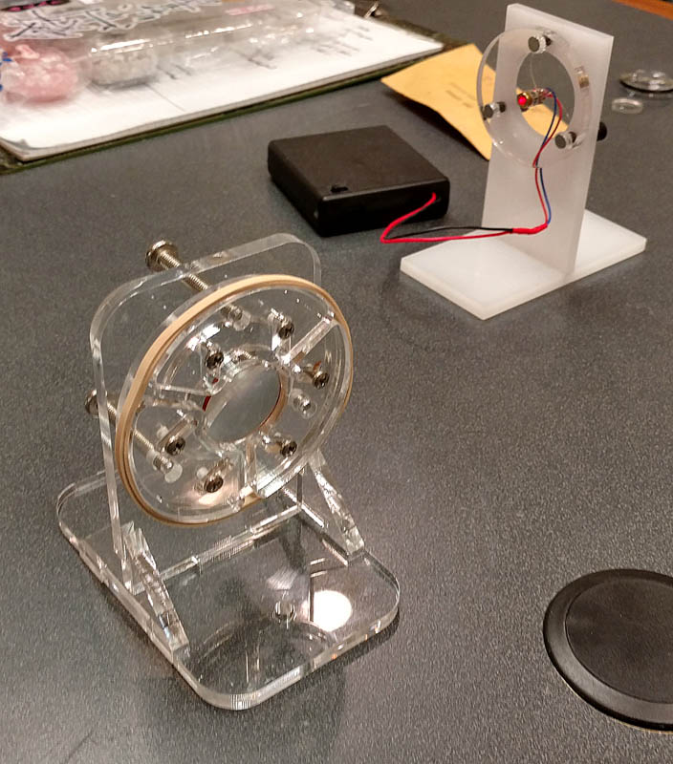

Polarizer Mount

Friday, April 22, 2016

11:19 AM

Two polarizers with a clear optical path between them will transition from all light through to no light through (or extinction) as angle between the rings goes from 0 degrees and 90 degrees. Different substances in the optical path cause the light polarization to rotate and by measuring the difference in extinction angle between a clear optical path and the path with the substance inserted the substance can often be determined.

The polarizer mount consists of two rings: the inner ring is attached to the Component Holder and the outer ring can freely rotate. A piece of polarizing film is cut and glued to the mount.

The outer ring is engraved at 5 degree increments for ease of measurement.

Laser Mount

Friday, April 22, 2016

11:24 AM

The laser mount consists of a lasercut ring with a XX diameter hole cut in the center which will admit a small laser. The laser battery pack can be velcroed to the component holder base.

LED Mount

Friday, April 22, 2016

11:27 AM

The LED mount consists of a lasercut ring with a XX diameter hole cut in the center which will admit an LED. A battery pack can be velcroed to the component holder base for powering the LED.

Detector Mount

Friday, April 22, 2016

11:48 AM

The detector mount consists of a lasercut ring with a XX diameter hole cut in the center which will admit an XXX detector.

Cuvette Mount

Friday, April 22, 2016

11:52 AM

A cuvette is a test tube designed for use in optical analysis. They are square or rectangular in cross-section to avoid refraction artifacts and are made from quartz, optical glass, or plastic depending on what part of the spectrum is under consideration and how demanding the measurement is.

The cuvette mount allows a cuvette to be slid into the mount and snapped to a component holder.

Iris diaphragm mount

Friday, April 22, 2016

11:57 AM

Depth of field or effective focus range is the distance between the nearest and farthest acceptably sharp objects in a scene. While a lens has perfect focus at only one distance, the sharpness falls off gradually on either side. Depth of field is subjective and based on whether the change in focus is perceptible or not.

The iris diaphragm mounts consist of apertures for controlling the depth of field of the optical path.

One common iris diaphragm is the pinhole which creates an infinite depth of field.

Reticle Mount

Friday, April 22, 2016

2:59 PM

A reticle is a clear device with cross-hairs used for aligning the optical path.